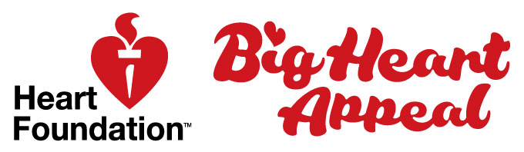

The Big Heart Appeal – Big Heart Day

<Name of your early learning service> are holding a Big Heart Day on <date> February 2021 to to learn what it means to have a healthy heart for life and at the same time raise funds to support life-saving heart research.
For our Big Heart Day we are going to:
- <details of your day>
- <details of your day>
- <details of your day>
- <details of your day>
- <details of your day>
We are having a Big Heart Day because we:
- Want to spread the word about being healthy
- Contribute to the Heart Foundation’s vital work
- Can celebrate Valentine’s Day at the same time
- Are learning about keeping our heart’s healthy
- Want to inspire our families to eat tasty and healthy food
- Could win some awesome prizes
- Other
- Other

We would love you to join us at our Big Heart Day. Help us to let the community know what we are doing to promote healthy hearts and the vital work of the Heart Foundation.
- <DATE>
- <TIME>
- <ADDRESS>

For more information, please contact:

